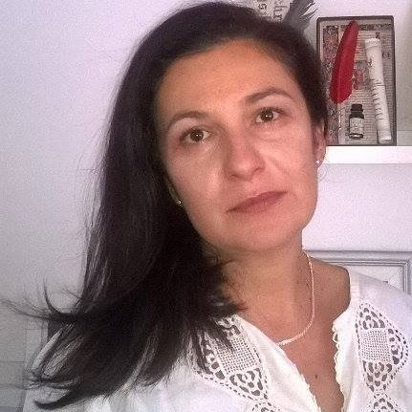

Ilijana Cutura, associate professor, is currently teaching grammar of the Serbian language at the Faculty of Education in Jagodina. Her main fields of interest are syntax, teaching Serbian as the mother tongue to zoung learners and new forms of communication, e.g. sms language, language of video games and internet communication. She is currently vice dean for teaching.
Ilijana Cutura has published over 50 papers and two books. She is a member of research teams in several international development projects, one international and one national scientific project.

